Lyng Primary School Knowledge Organiser
Topic: | The Maya  Human and Physical Geography | Year 4  Battles, beliefs and buildings | Autumn


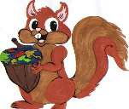
?
W
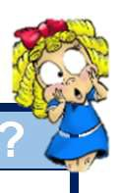
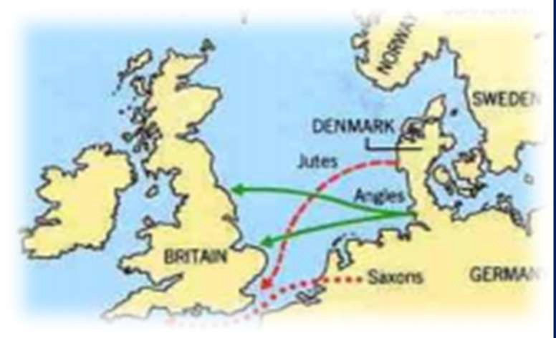

Let’s recap…

To discover more:

Rainforest Trust:
https://www.rainforesttrust.org/our-impact/success-stories/maya-forest/

The Nature Conservancy:
https://www.nature.org/en-us/about-us/where-we-work/latin-america/mexico/maya-forest/

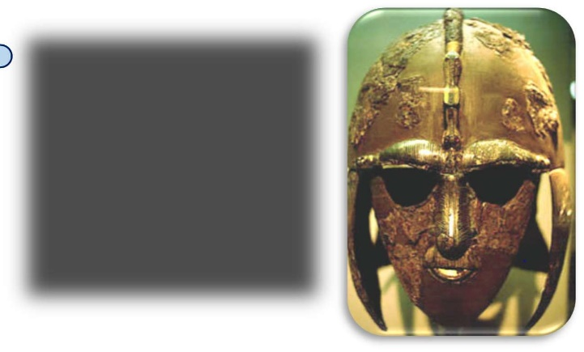
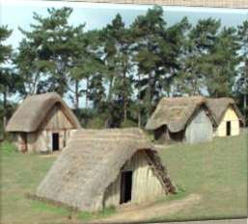
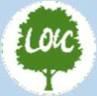

What Step On and Goldilocks words will I use?
Spelling | Definition
Chichen Itza | A village in Yucatan state in Mexico: site of important Mayan ruins.
civilisation | A human society with its own social organization and culture.
climate | The general weather conditions that are typical of a place.
deforestation | If an area is deforested, then all of the trees are cut down.
distribution | Delivering goods to a number of places.
emergent | Tall trees growing above the canopy.
Maya | A member of an indigenous people of Yucatan, Belize, and Guatemala.
Mesoamerica | Another name for central America.
nomadic | Nomadic people travel from place to place instead of living in one place.
Under storey | Trees just below the canopy.
vegetation | Plants, trees and flowers.

Fieldwork Opportunities

Cadbury World
Maya Rainforest Talk
Significant places
- Wyre Forest
- Copan – Honduras (Ancient Mayan City)
- Chichen Itza (City with a Mayan temple) – Mexico
- Yucatan Peninusula – Mexico
Our overarching question is: What were Mayan settlements like?
- What is a rainforest biome?
- Has each layer of the rainforest got a purpose?
- Where are the rainforests?
- Why are there so many layers to the rainforest?
- How are rainforests similar and different?
Enquiry Questions
Year 1 – children explore the Amazon rainforest and look understand the difference between the rainforest and our woodland.
Year 2 – children look at the climate in Australia and compare the weather and location to the UK.
Year 3 – children looked at Ancient Greece and explored the deciduous biomes.

Our Storytelling Approach to enhance engagement

People:  Mayan tribe | Place:  Rainforest | Problem:  Should we go to battle?  Who should rule?
Key facts and locations
Map to be studied

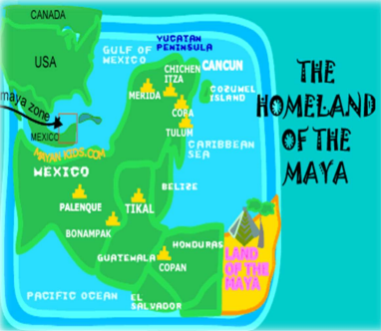


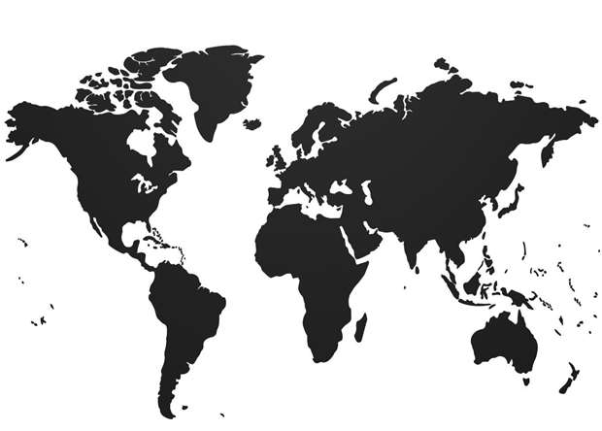
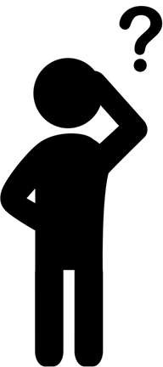
The Mayans live in Central America (Mesoamerica).

South America is the continent in which the Mayans lived.

The climate of South America is different to the UK.

The rainforest has trees in which animals live however, due to deforestation and the desire for natural resources, this is now changing at a fast rate.

Erosion, deforestation and pollution have a negative impact of the environment.

Mayan cities had similar layouts to each other. They would have a palace for the ruler, a plaza for the marketplaces and temples in the form of pyramids.

Maya cities were often found near trade routes and good farmland.

The demise of the Mayan civilization came about because of a mixture of deforestation, land erosion and drought.

Mayan ruins are still around today and so are some of the trade that they shared globally.


Lyng Primary School Knowledge Organiser
Topic: | Mayans  Human and Physical Geography | Year 4  Battles, Beliefs and Buildings | Autumn
